Theme/Term | 7 wks History- Romans |  |  | 7 wks Geography – Our planet, our world
writing | 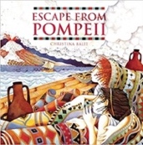  Escape from Pompeii  Christina Balit | 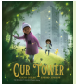  Our Tower  Joseph Coelho | Real purpose  School poetry competition  Poet study | 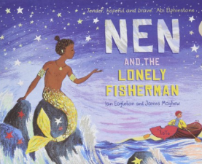  LGBTQ+  Nen and the lonely fisherman  Ian Eaglon | 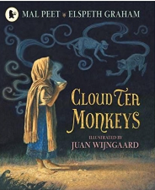  Cloud Tea Monkeys  Mal Peet |  |  | Real purpose
Outcomes | To inform  Newspaper reports  Setting descriptions, diaries, letters, thought bubbles | To entertain Extended fantasy narratives Poems, |  | To entertain- own narrative  character & setting description, , advert, diary | To inform- instructions and non-chronological report
reading | 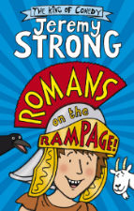  class novel  Romans on the rampage  Jeremy Strong | 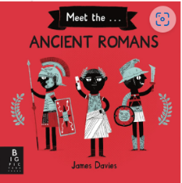  non-fiction  Meet the ancient romans  James Davies | Poetry  Our Tower  Joseph Coelho | 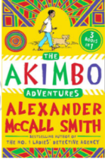  Class novel  Akimbo  Alexander McCall Smith |  |  | 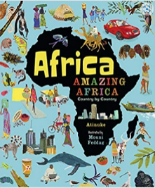  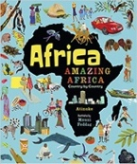  non-fiction  Africa, Amazing Africa  Atinuke | 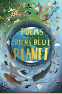  poetry  poems from a Green and Blue planet  Sabrina Mahfouz
Theme/Term | 5 wks History – Stone Age |  |  | 5 wks Geography- Rocks and Rumbles
writing | 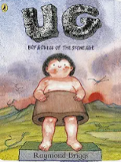  class novel  Ug  Raymond Briggs | 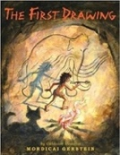  The First Drawing  Mordicai Gerstein | Real purpose  School poetry competition  Poetic style | 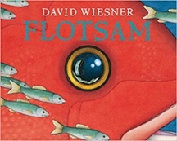  Flotsam  David Wiesner |  |  |  | Real purpose  Book for class library
Outcomes | To inform  Non-chronological report  instructios | To entertain  Own historical narratives  Character descriptions, diaries, recounts |  | To entertain & inform  Sequels (mystery narratives)  Setting descriptions, narrative retellings, non-chronological reports, letters (informal)
reading |  | 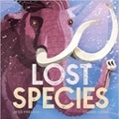  non-fiction  Lost Species  Jess French | 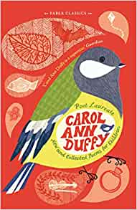  Poetry  New and Collected Poems for Children Carol Ann Duffy | 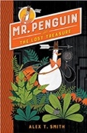  class novel  Mr Penguin and the Lost Treasure  Alex T. Smith | 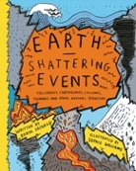  Non-fiction  Earth Shattering Events  Robin Jacobs
Theme/Term | 7 wks History- Ancient Egyptians |  |  | 7 wks Geography – Mountains & rivers
writing | 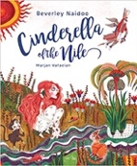  Cinderella of the Nile  Beverley Naidoo | 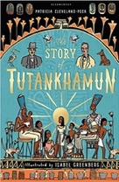  non-ficiton  The Story of Tutankhamun  Patricia Cleveland-Peck | Real purpose  School poetry competition  Performance poetry | 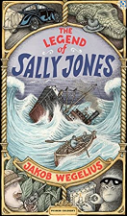  class novel  The legend of Sally Jones  Jakob Wegelius |  |  |  | Real purpose
Outcomes | To entertain - traditional fairy tale  Diary entry, character description | To inform – Biographies  Reports, instructions, character descriptions, diaries, newspaper, posters |  | To inform and entertain- newspaper article, diary entry, narrative
reading | 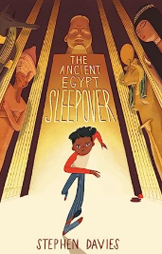  Class novel  The ancient Egypt sleepover  Stephen Davis |  |  | 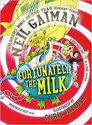  Fortunately, the Milk  Neil Gaiman |  | 