Theme/Term | History- Britain at war- Noor Inayat/ William Tull |  |  |  |  |  |  | Geography - Frozen Kingdom- Matthew Henson
writing | 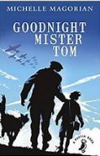  Goodnight Mister Tom  Michelle Magorian  class novel |  |  | 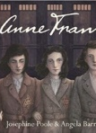  Anne Frank  Josephine Poole |  |  | Real purpose  School poetry competition  Poet study | 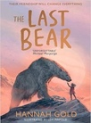  Class novel  The Last Bear  Hannah Gold |  |  | Real purpose  Persuasive letter to Birmingham City council- courageous advocacy
Outcomes | Write to persuade  Instructions, diary entry, persuasive letter |  |  |  |  |  |  | Write to inform  Non- chronological report; extended blog, newspaper article  Poetry, informal message, formal letter, short information text, diary entry, narrative and action scenes |  |  | Write to persuade
reading | Goodnight Mister Tom  Michelle Magorian | 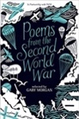  Poetry  Poems from the Second World War  Gaby Morgan |  |  | 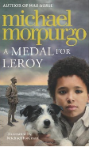  Non-fiction/fiction  A medal for Leroy  Micheal Morpurgo |  |  | The Last Bear  Hannah Gold |  | non-fiction  Darwin’s Voyage of Discover  Jake Williams  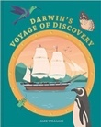 | 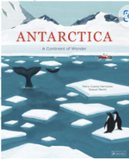  Non-fiction  Mario Cuesta Hernando
Theme/Term | History - Slavery & Civil Rights inc. Birmingham – Olaudah Equiano |  |  |  |  |  |  | Geography- our changing world -
writing | 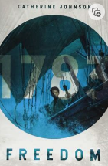  class novel  Freedom  Catherine Johnson |  | 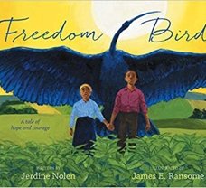  Freedom Bird  Jerdine Nolen |  |  | Real purpose  School poetry competition  Poetic style |  | 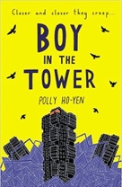  class novel  Boy in the Tower  Polly Ho-Yen |  |  | Real purpose  Book for class library
Outcomes | To inform  Newspaper report, diary entry |  | To inform  biography |  |  |  |  | To entertain narrative retelling  Warning posters, packing lists, journalistic writing, formal letters, non-chronological reports, narrative retellings
reading | Freedom  Catherine Johnson |  | Poetry  Caged Bird  Maya Angelou |  |  | non-fiction  Incredible Journeys  Levison Wood  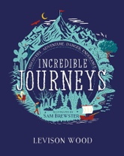 |  | Boy in the Tower  Polly Ho-Yen | 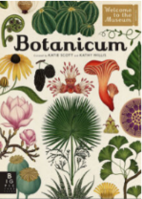  Non- fiction  Botanicum  Kathy Willis & Katie Scott
Theme/Term | History- Mayans |  |  |  |  |  |  | Goegraphy – South America
writing | 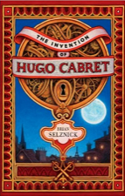  class novel  invention of Hugo Cabret  Brian Selznik |  | 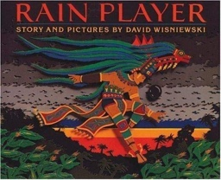  Rain Player  David Wisniewski |  |  | Real purpose  School poetry competition  Performance poetry |  | 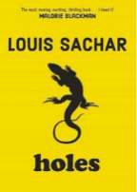  class novel  Holes  Louis Sacher |  |  | Real purpose  Survival guide for year 6/ secondary school?
Outcomes | To entertain  Flashback narrative, diary | To inform  Analytical essays about The Maya, debates |  |  |  |  |  | To explain  news report, persuasive text, survival guide
reading |  | 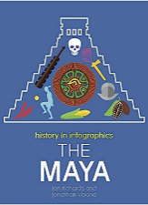  Non-fiction  History in infographics |  |  | 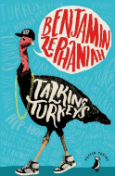  Poetry  Talking Turkeys  Benjamin Zephaniah |  |  | Holes  Louis Sacher |  | 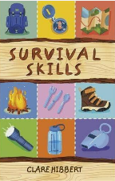  non-fiction  survival skills  Claire Hibbert

