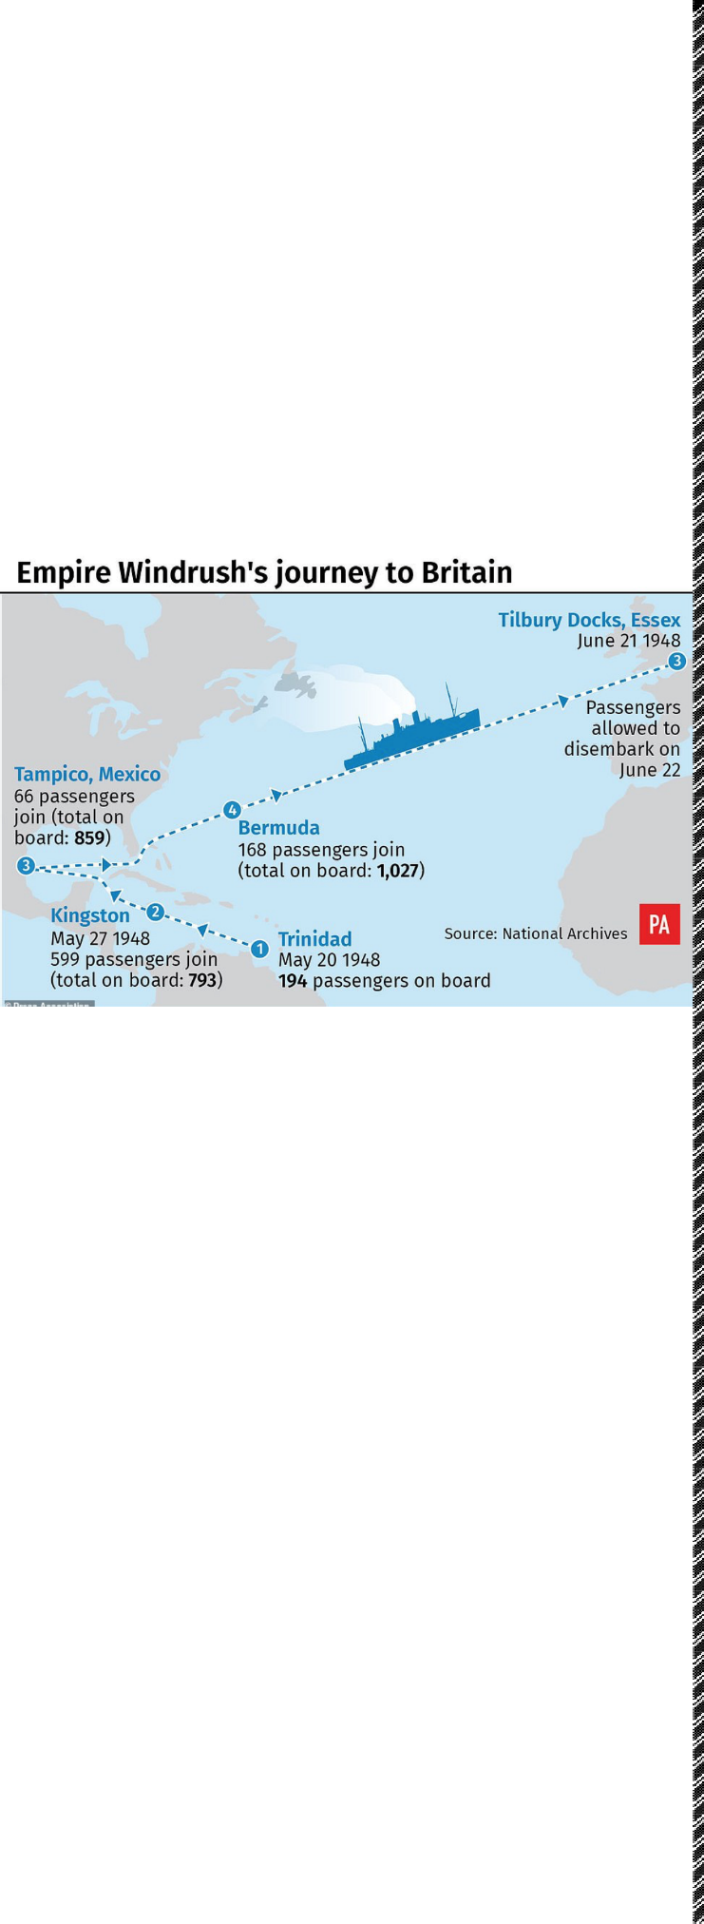



Year 4 - Windrush Knowledge Organiser

Key Vocabulary

|  |  |
| --- | --- |
| 1833 | Abolishment of slavery in Britain, enslaved Africans were now free. |
| 1931 | Creation of the Commonwealth of Nations – known commonly as the Commonwealth. |
| 1939 to 1945 | World War 2 |
| 21 June 1948 | The Empire Windrush docks at Tilbury, Essex carrying 1,027 passengers (and 2  stowaways), mainly from the Caribbean, hoping for a new life in Britain. |
| 2018 | A British political scandal concerning the “Windrush generation” that challenged the  right for these migrants and their families to reside in the UK despite being promised the right to remain. |

* **Empire** – a group of countries ruled over by a single monarch or ruling power.
* **Mother country** – the country that rules over its colonies.
* **Colonisation** – settlement and control over the people and location by those from another country.
* **Chattel slavery** – the legal ownership of one person by another.
* **The triangular trade** – the shipping of goods from Britain to West Africa to be exchanged for slaves. These slaves were shipped to the West Indies and exchanged/sold for sugar, rum, and other goods which were shipped back to Britain.
* **Middle Passage** – the transatlantic sea journey undertaken by slave ships from West Africa to the West Indies. It usually took between 6 and 11 weeks to complete the voyage.
* **The Americas** – all of North, Central and South America, including the West Indian islands (Caribbean).
* **Scrambles** – the auction at which slaves were sold. Buyers would scramble for the finest slaves.
* **Freedom** – the right to act, speak or think as one wants and not be imprisoned or enslaved by another.
* **Immigration** – the process of moving to another country with plans to live there forever.
* **Migrant** – a person who has chosen to live in a country where they were not born.
* **Citizenship** – being a legal member of a country and having rights there because of it.
* **Nationality** – a person’s nationality indicates which country they were born in.
* **Racism** – the belief that some races are better than others and the (racist) actions that can happen from those beliefs.
* **Commonwealth** – a legacy of Empire which has Queen Elizabeth II as its Head. (See ‘Extra information’).
* **Deportation** – to force someone to return to the country they came from usually because they have no legal right to be there or because they have broken the law.
* **Windrush Generation** – those that came to the UK from (mainly) the West Indies at the invitation of the British government to live and work. This includes their children who did not have their own passport but travelled on their parent’s passports.

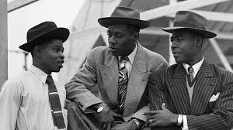

Some facts!

* HMT Empire Windrush was used to bring the West Indian migrants to Tilbury Docks, Essex, UK. It was originally called MV Monte Rosa and was a cruise ship and then a German navy ship in World War 2. The UK captured it during the war and renamed it ‘Empire Windrush’.
* The Commonwealth – all 53 countries were at one time associated with the British Empire. They all are individual with their own systems: not ruled over by another country. They are all regarded as equal and share common goals. Queen Elizabeth II serves as the Head of the Commonwealth.
* Between 1948 and 1970, nearly half a million left their homes in the West Indies to start a new life in the UK.

In 1948, Britain was starting to recover from World War 2. Thousands of buildings had been bombed and lots of houses were destroyed – it all needed to be rebuilt.

Many Caribbean men and women had served in the British armed forces because at the time, many West Indian islands were still under British rule (empire) and not yet independent.

After the war, some of these people answered an advert to come to Britain where there were lots of different jobs to do.

Other people just wanted to see Britain which they had heard too much about.